A Heavenly Citizenship, Lesson 7
Adult Bible Study Guide, 2026 1Q, "Uniting Heaven and Earth--Christ in Philippians and Colossians"
 The Teacher's Notes — February 7, 2026
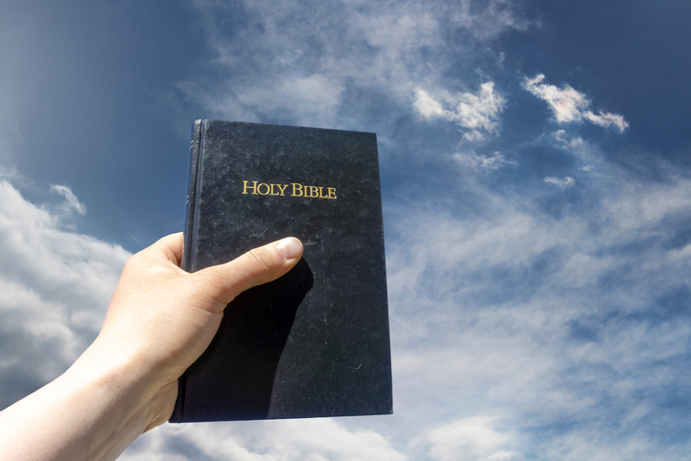
Sabbath School Lesson for February 7-13, 2026
Introduction of Lesson 7, A Heavenly Citizenship
Memory Text: “Be anxious for nothing, but in everything by prayer and supplication, with thanksgiving, let your requests be made known to God.” Philippians 4:6 NKJV
Governments of most countries of the world are disappointing to those who long for citizenship in heaven. Many are feeling quite anxious by how corrupt and aggressive their governments have become. We watch and pray as former countries of power and influence are changing rapidly, making it a scary time for us all to live on the earth.
At the end of Paul’s epistle to the Philippians, we are given wise counsel that can bring us inner courage and strength to survive the various, current challenges we experience.
The high moral values that Paul exemplified in his life and mentioned in his letter can lead us to a place closer to God’s throne and closer to our heavenly Father’s kingdom. Praying with thanksgiving, thinking about good things, and being gentle and forgiving are ingredients for a better existence now and a glorious one in our future home in heaven.
- Sunday: Role Models
- Monday: “Stand Fast in the Lord”
- Tuesday: Rejoice in the Lord–Always
- Wednesday: Think on These Things…
- Thursday: Keys for Contentment
Sunday: Role Models
Role models, although needed, can obviously be good or bad. Unfortunately, there is no shortage of bad ones in this world. Media presents them to us in dazzling, enticing ways. Don’t be fooled by glittering, glamorous lifestyles. The end result is often disappointing and even dangerous.
As Paul described the ones we are not to model our lives after, he does it with heartfelt weeping and sorrow (Philippians 3:18). He knows that their end will be destruction. They have set their hearts on earthly things. Selfishly wanting temporary satisfaction and joy, their god is their appetite. Having made their bellies their god, as Paul described it (Philippians 3:19).
Paul characteristically doesn’t call these bad examples HIS enemies. To him, they are “enemies of the cross of Christ” (Philippians 3:18). Only with a loving attitude can we break down barriers and foster unity with those who disagree with us. Focusing on the sacrifice and love of Christ, remembering that we all fall short of His glory, can help heal broken relationships and help us come together in unity.
Verses and questions:
Philippians 3:17
- Why is it important to have good role models?
- What kind of role model do you try to present to others?
- In what ways would you like to improve your influence on others?
Philippians 3:18
- Who and why did some people make Paul sad?
- How should we treat those we might see as “enemies of the cross of Christ”?
Philippians 3:19
- What does it mean by saying that their “god is their belly”?
- What kind of things should we be focusing on?
Monday: “Stand Fast in the Lord”
With bad influences surrounding us everywhere, Paul reminds us to keep holding on to the Lord. There’s no better person to pattern our lives after than Jesus Christ. We can trust His power to change us. He not only transforms us in this life, but is so powerful, He can change our mortal bodies into immortal, glorious ones at the resurrection (1 Corinthians 15:53).
Death is called “the last enemy” (1 Corinthians 15:26), both perhaps because we experience it at the end of our time on earth, but also because it will be the last enemy God removes from us at the final judgment. The second death, when the wicked are burned up, destroyed forever (Revelation 20:14), will be the end of our “last enemy”.
We know we have been saved when the fear of death is overcome and Satan ceases to control our life through fear. We trust in the Lord to save us from death, so it doesn’t seem as scary or mysterious any more. Standing fast in God’s power to save us ideally casts away all our fears (1 John 4:18).
Verses and Questions:
Philippians 3:20, 21 and 1 Corinthians 15:42-44
- What kind of bodies will we have at the resurrection?
1 Corinthians 15:26
- Why is death called “the last enemy”?
Tuesday: Rejoice in the Lord–Always
Rejoicing, having joy, is something Paul mentioned over and over in his epistles. It doesn’t just sound like good advice when Paul talks about it. It definitely is intended to be a command. It’s especially amazing to us that Paul kept repeating this theme of joy and contentment while he himself was in prison.
When we pray to God in faith, we find an antidote, a remedy, for our anxiety and worry. Making our requests known to God, and thanking Him for everything, enables us to experience joy in the midst of whatever pain we might be going through.
Combined with a lifestyle that is gentle and forgiving toward others brings us to a place in our relationship with Christ that is full of peace and joy. God is our strength and peace (Psalm 29:11). Jesus is the Prince of peace (Isaiah 9:6), and we know the Holy Spirit casts out fear and brings us peace (John 14:27). We rejoice in the fact that God is not the author of confusion, but rather the author of our peace (1 Corinthians 14:33).
Verses and questions:
Philippians 4:4-7
- What are some of the ways we can have both joy and peace in our Christian journey?
- Which one of these recommendations do you find hardest to accomplish–being happy, not worrying, or being gentle with others?
- What tangible ways are there for us to improve our ability to have peace and joy?
Matthew 6:25 and 1 Peter 5:7
- What are the reasons given here for us to not worry?
Wednesday: Think on These Things…
Paul doesn’t leave us guessing when it comes to having peace. He outlined specific actions we can take to ensure we have those things that bring us peace.
According to Paul, peace is something that guards our hearts and minds. Being tethered to a Roman soldier guard, he recognized that his heart and mind were still free. Using the military metaphor of a guard helps us appreciate Paul’s words in Philippians 4:8, 9. His mind was still free to think on good things and even to practice the love and forgiveness he had learned from Christ’s example.
Our minds are free to focus on things we know to be true, noble (also translated “reverent”), righteous, pure, lovely (including the beauty of God’s creation), and admirable (those things that make us kind, winsome, and gracious). If we want to have peace for ourselves, our thoughts must trend naturally and often to these praiseworthy virtues.
Verses and questions:
Philippians 4:7 and Jeremiah 17:9
- Why do we need a guard on our heart?
Philippians 4:8, 9, Luke 21:26, and 1 John 4:18
- What specific actions can we take in order to have peace, as opposed to fear, in our hearts?
Thursday: Keys for Contentment
Paul ends his epistle with many noteworthy statements that have become precious to Christians everywhere and for all time. They include keys for the kind of contentment that lead to having peace and joy; such as caring for each other, looking for things to be thankful for, and doing everything with the power Christ freely gives us.
Keys that bring us closer to God are in Paul’s observations that he could do all things through Christ, who strengthened him (Philippians 4:13). And that God would supply all his needs (Philippians 4:19).
Some of those needs which we can safely pray for, knowing they are in God’s will, are:
- Salvation for ourselves or someone else (1 Timothy 2:3, 4)
- Courage to share our faith (Acts 1:8)
- Forgiveness when we confess and forsake sin (1 John 1:9)
- Strength to obey God (Hebrews 13:20, 21)
- Love for our enemies (Matthew 5:44)
- Wisdom in making good choices (James 1:5)
- Understanding truths in the Bible (John 8:32)
Verses and questions:
Philippians 4:10-13
- What keys does Paul recommend that will help us be content?
Philippians 4:19
- How do we achieve all the things we need?
- What kind of things can we safely pray for that are in God’s will?
Friday: Final Thoughts
As Christians, we long for our heavenly home, but Paul reminds us that privileges of heavenly citizenship can be enjoyed even now, when we put our trust and faith in the King of the universe.
Ellen G. White beautifully expressed these privileges in a book called That I May Know Him, p. 224…
“There is not a burden but He can remove, no darkness but He can dispel, no weakness but He can change to power, no fears but He can calm; no worthy aspiration but He can guide and justify.”
Joy and peace are indeed possible even now, as long as we stay close to our heavenly Father.
Next Week: The Preeminence of Christ
To read the Sabbath School Lesson Quarterly and see more resources for its study, go to
https://www.sabbath.school/

